- Automation vs autonomy
- MCP Client/Server design has official tutorial
- One idea could be pre-training one neural network to output an estimate of “expected” optimal configuration. And then run further precise optimization from that starting point.
- Design Idea #1: Separate into MCP Server (wrappers around different components with exposed tools), and Run Engine / Orchestrator (MCP Client using access pre-trained LLM and the “fine optimization loop (stochastic or not)” to move components by interfacing with server)
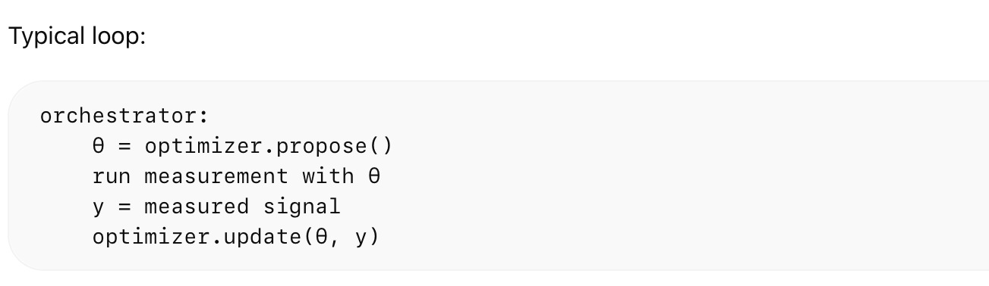
- Cobolt has remote interlock connector behavior. Closed interlock = good
- For Cobolt control, could use official python (pycobolt) or community automation packages (PyLabLib)
- Integrate “safe shutdown” to return system to safe configuration.
- For future system expansion, could consider/inspire from existing systems to facilitate typical automation things like parameter sweep: Bluesky, QCoDeS
- Consider dither locking for fine tuning coupling. Requires small dither frequencies, thus requires fast enough detector.
- Note that beam walking scales poorly and technically doesn’t optimize for coupling with detector but rather for geometric alignment
- Possible objective function:
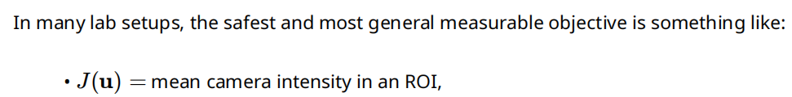
- Related paper about autonomous alignment of beamlines in synchrotrons using Bayesian optimization: https://pmc.ncbi.nlm.nih.gov/articles/PMC11542659/#sec7
- For more higher dimensions (uses local Bayesian optimization): https://arxiv.org/abs/1910.01739
- Other possibilities exist like stochastic approximations for even more dimensions like CMA-ES or SPSA
- If intrinsic / effective dimensionality is low (uses lower dimension Bayesian optimization): https://arxiv.org/abs/1301.1942
- Could also consider RL but you need rich observation (not just detector intensity, single scalar). Training should also be cheap. Check this out: https://papers.neurips.cc/paper_files/paper/2020/file/99ba5c4097c6b8fef5ed774a1a6714b8-Paper.pdf
- Already some existing optimizers though such as M-Loop. Could use it for intial demonstration or just as benchmark. See use cases of M-Loop: https://arxiv.org/abs/2010.15246, https://www.nature.com/articles/srep25890
- Include noise considerations for simulation

